**//Basic assignment problems for today...**

**//done by 20nu1a05a6**

#include<iostream>

using namespace std;

int main()

{

int n;

cout<<"enter a number:";

cin>>n;

if(n%2==0)

{

cout<<n<<" is even number";

}

else

{

cout<<n<<" is odd number";

}

return 0;

}

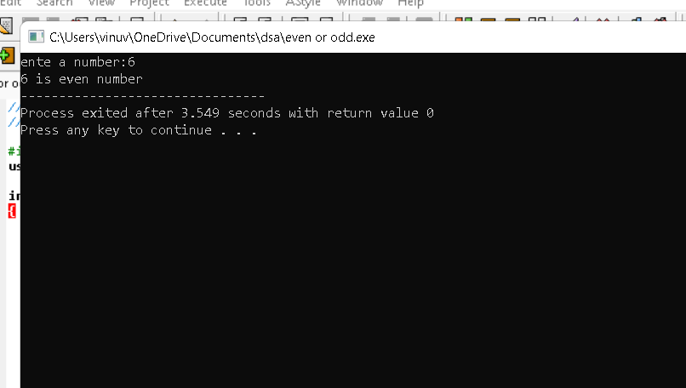

//reverse of number

#include<iostream>

using namespace std;

int main()

{

int n,rev=0,rem;

cout<<"enter a number:";

cin>>n;

while(n!=0)

{

rem=n%10;

rev=rev*10+rem;

n/=10;

}

cout<<"reverse of "<<n<<" is :"<<rev;

return 0;

}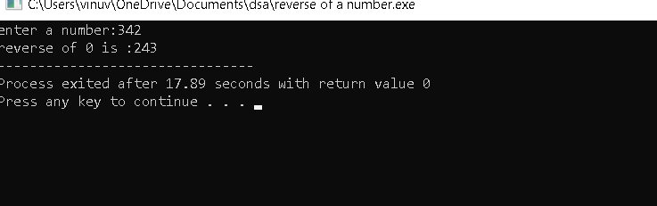

3. //factors of a given number.....

#include<iostream>

using namespace std;

int main()

{

int n,i;

cout<<"enter a number:";

cin>>n;

for(i=1;i<=n;i++)

{

if(n%i==0)

{

cout<<"factors of "<<n<<" is:"<<i<<endl;

}

}

return 0;

}

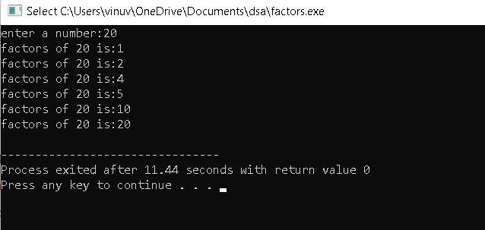

//prime number.....

#include<iostream>

using namespace std;

int main()

{

int n,i,c=0;

cout<<"enter a number:";

cin>>n;

for(i=1;i<=n;i++)

{

if(n%i==0)

{

c++;

}

}

if(c==2)

{

cout<<"prime number";

}

else

{

cout<<"not prime number";

}

return 0; }

